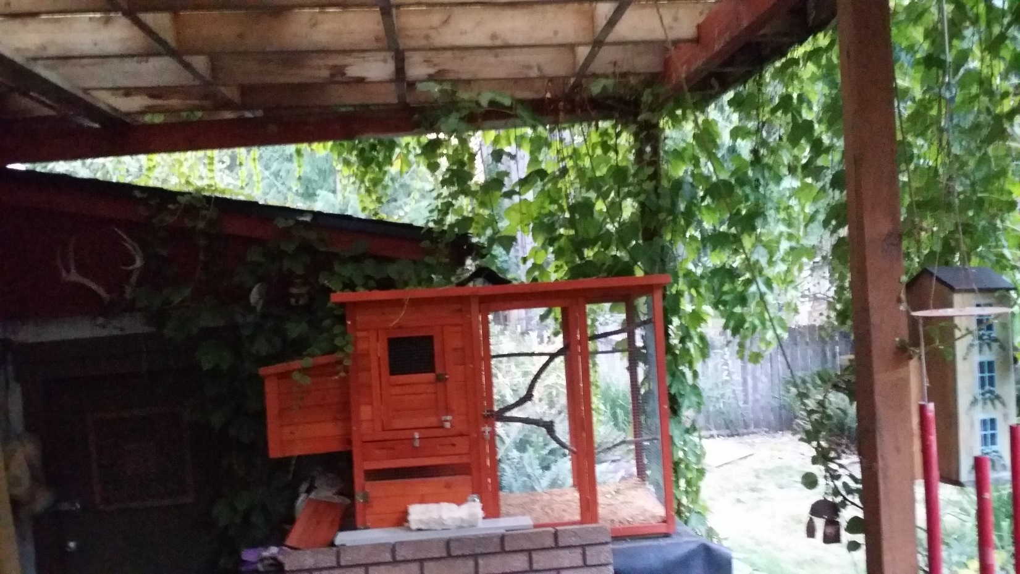**PIGEON/DOVE HOME**